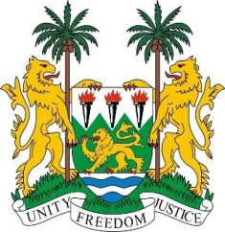
SIERRA LEONE
22nd Session of the UPR

BULGARIA

7 May 2015

Mr President,

Sierra Leone welcomes the delegation of Bulgaria and thanks them for their comprehensive update of their national report.

My delegation notes with appreciation the ongoing reform of Bulgaria’s judiciary and the efforts to integrate into national laws, various international instruments including among others, the ICCPED, the Convention on the Rights of Persons with Disabilities and the Convention on the Reduction of Statelessness. My delegation also commends the anti-trafficking measures that are implemented by the government.

Sierra Leone would however encourage Bulgaria to effectively address and implement policies to address violence perpetuated against ethnic and religious minorities, (including Jews, Roma and Muslims). In addition, my delegation urges the Government of Bulgaria to combat gender stereotypes and further promote gender equality by ensuring that women have equal access to the public and political positions.

Sierra Leone has the following recommendations:

- Ratify the ICRMW.
- Prosecute the instigators of hate crime and provide remedies for victims of hate speech.
- Eliminate all forms of child marriage and raise the minimum age of marriage to 18.
- Develop policies to effectively prevent violence against women, in particular, domestic violence and also provide shelters and assistance to victims.

Sierra Leone would like to conclude by wishing Bulgaria a successful completion of their national review cycle.

Thank you, Mr President.

